**CACREP Executive Summary**

**Introduction:**

The George Washington University’s Department of Counseling and Human Development has spent about two years developing the documents required for the next accreditation cycle for CACREP. Some of these issues include formatting course syllabi to meet the standards, setting up data collection in Taskstream, collecting and evaluating data, writing the self-study, and creating the program evaluation plan.

Below is a chart of Enrollment data for all GWU’s Counseling and Human Development academic programs from 2016-2019. This chart shows the number of applicants, admission offers and committed new students to each program.



Below is a Bar Chart of GWU Student Enrollment Data by Gender and Ethnicity for all academic programs from 2016-2019.

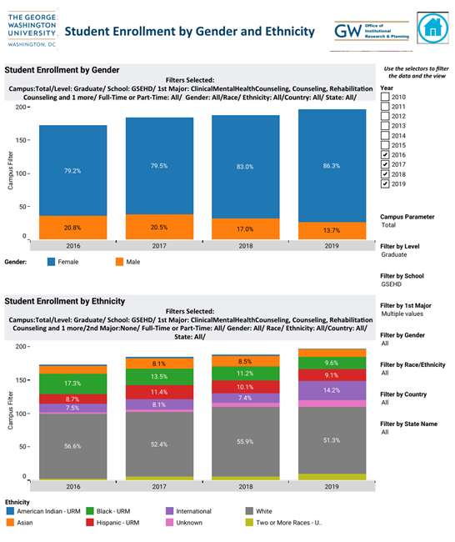

Below is a table showing GWU Student Enrollment data by Gender and Ethnicity for all CHD academic programs from 2016-2019.

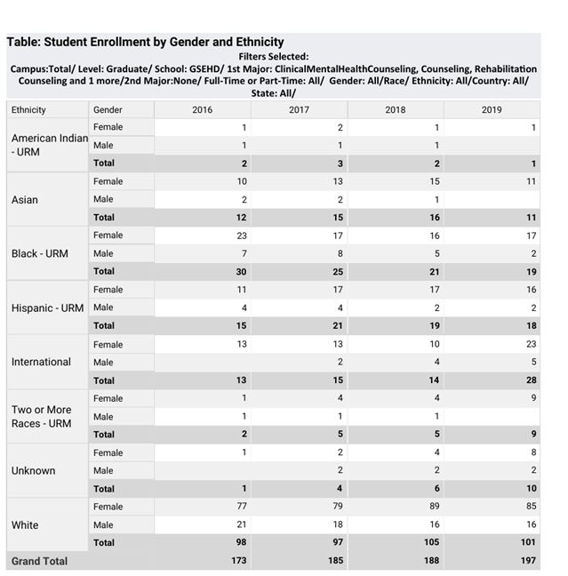

GWU’s CHD students are required to take the Counselor Preparation Comprehensive Examination (CPCE) as a standardized measure of knowledge and skill acquisition on the CACREP Domains. August 2019 is the latest data, and these were our student’s scores:

**GW Mean (SD)** **National**

Human Growth and Development 13.5(1.9) 9.6(2.7)

Social/Cultural Diversity 12.2(1.8) 10.8(2.4)

Counseling/Helping Relationships 11.8 (2.0) 9.4(2.6)

Group Counseling/Group Work 13.7(2.0) 11.3(2.5)

Career Development 11.2(2.6) 9.9(2.4)

Assessment/Testing 10.3(2.2) 9.0(2.5)

Research/Program Evaluation 13.2(2.1) 9.6(2.7)

Professional Counseling Orientation and

Ethical Practice 11.2(2.9 10.8(2.4)

Total CPCE Results: 97.1(14.3) 81.4(14.7)

NCE Exam Results: 100% 91%

CRC Exam Results: 100% 69%

These scores show a strong performance by GW students on the eight core counseling standards, which forms the foundation for the specialty course knowledge and contextual factors. Each CACREP Standard is described, and the course(s) which cover this standard are highlighted in the Program Evaluation Plan, along with sources of evidence. In addition, the national certification exam results provide evidence that GWU’s graduates are well prepared for the credentialing exams and employment.

CHD TaskStream Evaluation Response Graphs from July 2019-July 2020:

**Program Improvements**:

The George Washington University’s Counseling & Human Development Department faculty has created plans of improvement for each specialty program (Clinical Mental Health Counseling, Rehabilitation Counseling, School Counseling, and Doctorate in Counseling). Here is a summary of program improvements for each specialty program. In the last three years, the focus has shifted from program evaluation across the Core standards to the specialty specific standards described in Standard 5 for the MA programs. At the doctoral level, the focus is on Standard 6.

Clinical Mental Health Counseling Program

Improvements were made for the Clinical Mental Health Counseling Program by analyzing all categories for Standard 5 for the specialty of Clinical Mental Health Counseling. The standard scores were below 2.5 in student performance for the Counselor Identity and Multicultural Competence standards. These were clustered in knowledge and skill areas, with several themes. One theme was knowledge of the role of ethics and legal considerations as these have evolved historically. To address this, the faculty has decided to move from having adjunct faculty teach the ethics and professional identity course to having core counseling faculty teach it. The faculty has begun a years-long process to examine every area from curriculum to faculty and student recruitment, to faculty training and development.

Another knowledge deficit we noted was the counselor as advocate. Because this ties in nicely to the third area of attention, namely multicultural competence, we will build in an advocacy role for students, faculty, and staff, and will ensure that, as one standard requires, we engage in dialogue with other perspectives, other cultures, and other worldviews. At the skill level, we plan to add both a diagnostic and a treatment planning component to applied courses, from interview skills, to theories/techniques, to trauma and crisis intervention. As we review the curriculum, skill building in these areas will be examined with an anti-racist and culturally sensitive lens.

Rehabilitation Counseling Program

Improvements were made for the Rehabilitation Counseling Program by analyzing all categories for Standard 5 for the specialty of Rehabilitation Counseling. The standard scores were below 2.5 in student performance for the Counselor Identity and Multicultural Competence standards. These were clustered in knowledge and skills areas identified as ethics, advocacy, and multicultural competencies. To address these, the faculty has agreed to ensure that only core regular status faculty, not limited service faculty/adjunct faculty, instruct the ethics course, the theory course, and the rehabilitation counseling professional identity courses including practicum and internship.

Another knowledge deficit we noted was the counselor as advocate. Because this aligns with student multicultural competence, the faculty has begun a years-long process to examine every area from curriculum to faculty and student recruitment, to faculty training and development. We will build in an advocacy role for students, faculty, and staff, and will ensure that, as one standard requires, we engage in dialogue with other perspectives, other cultures, and other worldviews. At the skill level, we plan to add both a diagnostic and a treatment planning component to applied courses, from interview skills, to theories/techniques, to trauma and crisis intervention. As we review the curriculum, skill building in these areas will be examined with an anti-racist and culturally sensitive lens.

School Counseling Program

Improvements were made for the School Counseling Program by analyzing all categories for Standard 5 for the specialty of School Counseling. The standard scores were below 2.5 in student performance for the Contextual Dimension of School Counseling and Practice of School Counseling standards. Areas in need of further attention include competency to advocate for school counseling roles; professional organizations, preparation standards and credentials relevant to school counseling; legal and ethical considerations specific to school counseling as foundational to the field of school counseling; techniques of personal/social counseling in school settings; and skills to critically examine the connections between social, familial, emotional, and behavior problems and academic achievement.

To support students in the development of contextual dimensions of school counseling, the program has created a new required course entitled Coordination of Comprehensive Guidance Programs (CNSL 6467). It has also been decided that courses teaching ethics, Interviewing skills, theories and techniques of counseling, and family counseling will all be taught by core faculty with skills and knowledge specific to these courses, including education in the topic and clinical experience. Additionally, Interview Skills was taught as a seven-week course but has now been transitioned into a 14-week course to allow for more intensive and comprehensive skill building. Family Counseling has alternated between a multi-weekend course and a 7-week course. It will now only be taught as a 7-week course to ensure full transmission of relevant knowledge and skill.

Doctorate in Counseling Program

Improvements were made for the Doctorate in Counseling Program by analyzing categories for Standard 6 for Counselor Education and Supervision. The standards on supervision and teaching core areas were the focus. Standards for the doctoral core area in supervision are primarily evaluated via faculty evaluations of student performance as supervisors in master’s level practicum courses that serve clinical mental health, school, and rehabilitation counseling. Across the eleven supervision standards, students averaged 2.93/3 (*sd* = 0.09). Students met or exceeded expectations on all standards for this area of supervision. No program improvements were made for these sets of standards.

Standards for the doctoral core area in teaching are primarily evaluated via faculty evaluations of student performance as instructional assistants (or teaching assistants) in master’s level counselor education courses that serve clinical mental health, school, and rehabilitation counseling. Across the nine teaching standards, students averaged 2.38/3 (*sd* = 0.33). Students met or exceeded expectations for doctoral teaching core area standards in 8 of 9 instances. Based on the teaching standards, a program improvement was made: “Beginning summer 2021 content for teaching philosophy statements will include a section on the role of mentoring in counselor education.”

**Empirical Data:**

This section contains a summary of empirical data of student performance for standards for the eight common areas (2.F.1-8) and for each program: Clinical Mental Health Counseling (5.C.1-3), Rehabilitation Counseling (5.H.1-3), School Counseling (5.G.1-3), and Doctorate in Counseling (6.B.1-5).

**Standards for the Eight Common Areas**

For Standard 2.F.1, **Professional Counseling Orientation and Ethical Practice**, the overall average performance for sub-standards 2.F.1.A-M ranged from 89.37% to 94.06%.

For Standard 2.F.2, **Social and Cultural Diversity**, the overall average performance for sub-standards 2.F.2.A-H ranged from 90.38% to 96.49%.

For Standard 2.F.3, **Human Growth and Development**, the overall average performance for sub-standards 2.F.3.A-I ranged from 90.09% to 95.85%.

For Standard 2.F.4, **Career Development**, the overall average performance for sub-standards 2.F.4.A-J ranged from 88.03% to 100%.

For Standard 2.F.5, **Counseling and Helping Relationships**, the overall average performance for sub-standards 2.F.5.A-M ranged from 80.83% to 95.13%.

For Standard 2.F.6, **Group Counseling and Group Work**, the average rubric score across sub-standards 2.F.6.A – H, was 92.46%.

For Standard 2.F.7, **Assessment and Testing**, the average rubric score across sub-standards 2.F.8.A – M, was 95.54%.

For Standard 2.F.8, **Research and Program Evaluation**, the average rubric score across sub-standards 2.F.8.A – J, was 92.48%.

**Clinical Mental Health Counseling**

For Standards 5.C.1.A – E, the overall average performance of candidates ranged from 85.8% to 96.66%. For Standards 5.C.2.A – M, the overall average performance of candidates ranged from 75.44% to 97.76%.For Standards 5.C.2.A – E, the overall average performance of candidates ranged from 83.34% to 97.27%.

**School Counseling**

For Standards 5.G.1.A – D, the overall average student performance ranged from 87.28% to 100%. For Standards 5.G.2.A – N, the overall average student performance ranged from 87.28% to 100%. For Standards 5.G.3.A – O, the overall average student performance ranged from 80.56% to 100%.

**Rehabilitation Counseling**

For Standards 5.H.1.A – G, the average rubric score across all students ranged from 88.3% to 93.75%.For Standards 5.H.2.A – R, the average rubric score across all students ranged from 83.95% to 100%.For Standards 5.H.3.A – M, the average rubric score across all students ranged from 91.59% to 92.03%.

**Doctorate Program in Counseling**

GWU is collecting data on the missing CACREP standards (e.g., 6.B.1.A-E) during the 2020-2021 academic year. GW will have these data available for the site reviewers when they visit GWU. For Standard 6.B.1.F, **ethical and culturally relevant counseling in multiple settings**,candidates had an overall performance of 100%. For Standards 6.B.2.A – K, the average performance of candidates ranged from 88.1% to 100%. For Standard 6.B.3.A – I, the average performance of candidates ranged from 66.65% to 90%.

GWU is collecting data on the missing CACREP standards (e.g., 6.B.4.A-K) in the 2020-2021 academic year. GWU will have these data available for the site reviewers when they visit GWU. For Standard 6.B.4.L, **ethical and culturally relevant strategies for conducting research**,candidates had an overall performance of 100%.

GWU is collecting data on the missing CACREP standards (e.g., 6.B.5.A-J, 6.B.5.L) in the 2020-2021 academic year. GW will have these data available for the site reviewers when they visit GWU. For Standard 6.B.5.K, **strategies of leadership in relation to current multicultural and social justice issues**,candidates had an overall performance of 100%.